GP Extended Access Bookable Service
Where do I go for my appointment?
Brambles Surgery, Greenwich Avenue
Brentwood, CM15 9DY

The service is located on the ground floor

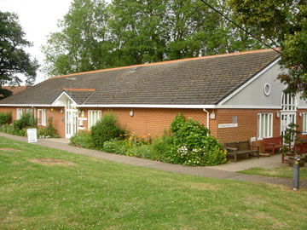
ACE Limited GP Federation
The GP Extended Access Service is provided by Accountable Care Enterprise. Accountable Care Enterprise is wholly owned by the GP practices in Brentwood, working together on behalf of practices, patients, and staff to deliver safe, effective and responsive healthcare services.

This information can be made available in alternative formats, such as easy read or large print, and may be available in alternative languages, upon request. Please contact ace.ltd@nhs.net
GP Extended Access Bookable appointment Service
There are now more appointments with GP`s and Nurses available in Brentwood, making it easier for you to get an appointment at a time that suits you in the evenings and weekends

When are these appointments available?
Appointments are available from 6.30pm – 8.30 pm Monday to Friday, 9am – 5pm Saturday.
Who can access these appointments?
Anyone registered with a GP practice in Brentwood.
What can I be seen for?
A GP Extended Access appointment is exactly like an appointment at your own GP practice
How do I book a GP or nurse appointment?
Contact your GP practice in the usual way to request an appointment. If there are no suitable appointments available at your practice, they may offer you an appointment with the GP Extended Access Service, if this is right for you.
In the case of urgent need when the practice is closed you can call NHS 111 (dial 111) to speak to a triage nurse. Your needs will be assessed and advice offered or arrangements made for you to see a doctor.
Call 999 in an emergency. Chest pains and / or shortness of breath constitute an emergency.
Will I see my own GP and/or nurse?
You will be seen by registered GP`s and Nurses, but it is unlikely that you will be seen by your own GP or nurse. If you would prefer to see your usual GP or practice nurse, please book an appointment with your usual practice during their normal opening hours.

Will the GP/Nurse I see have access to my medical record during my appointment?
Your medical record will, with your consent, be available to the GP/ Nurse that sees you, to ensure that they have the information they need to give you the best possible care.
Notes of your appointment will be sent back to your own GP practice electronically to ensure that your record is up-to-date.
How do I cancel an appointment?
If you need to cancel an appointment, please call 07757719333 and leave a message stating your name and the time and date of your appointment with the GP Extended Access Service.

